Problem 1: Circle Class
Objective:
- To create a Circle class with radius and area
- To initialize multiple circles and calculate their areas and total area
Theory:
A circle is defined by its radius and its area can be calculated using the formula Area = π*r*r. OOP allows the radius and area calculation method to be combined into a single class. This makes it easier to manage multiple circles and perform operations on each object separately
Code:
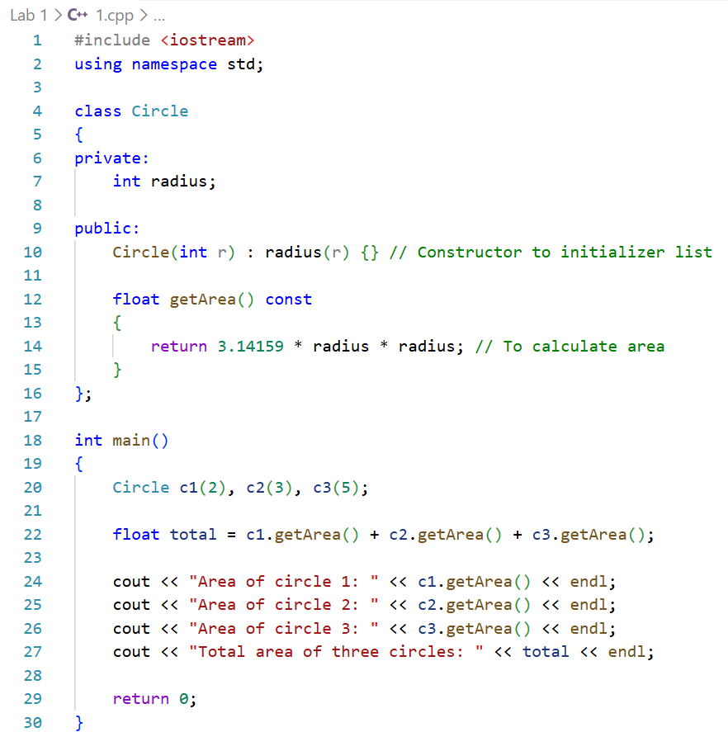
Procedure:
- The Circle class was created with radius as a private member
- A method to calculate area was written
- Three Circle objects were initialized in main
- Individual areas and total area were calculated and displayed
Output:
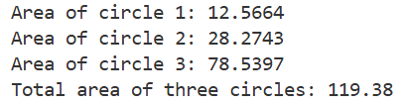
Precautions:
- Radius should be positive
- Formula should be correctly implemented
Conclusion:
The area of each circle and the total area were successfully calculated using the Circle class. Object-oriented programming was demonstrated effectively by handling multiple circle objects with their own data and methods

Problem 2: Account Class
Objective:
- To create an Account class to simulate banking operations
- To perform deposit, withdrawal, transfer and display balances
Theory:
A bank account has an account number and a balance. Deposit increases the balance, withdrawal decreases it and transfer moves money from one account to another
Code:
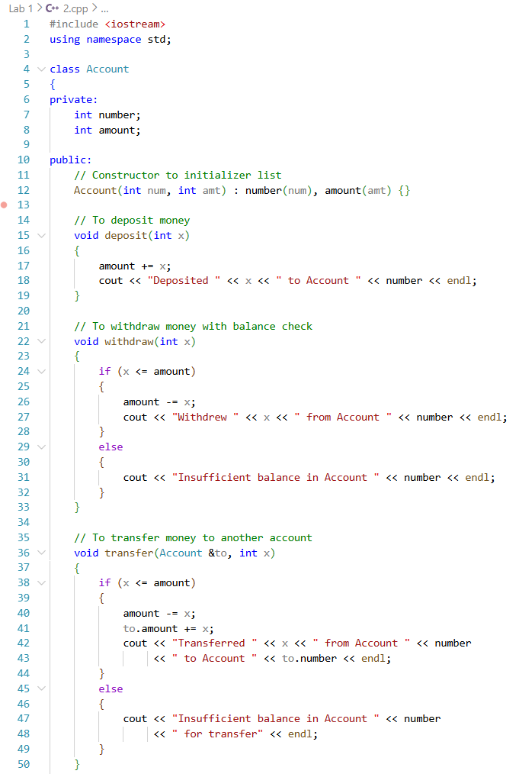
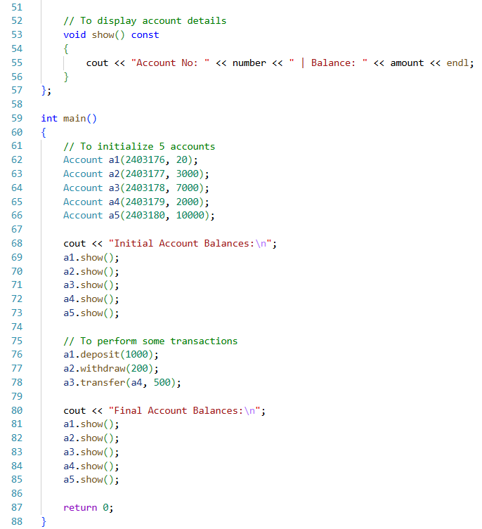
Procedure:
- The Account class was created with account number and balance
- Deposit, withdrawal, transfer and display methods were implemented
- Accounts were initialized in main
- Transactions were performed and final balances were displayed
Output:
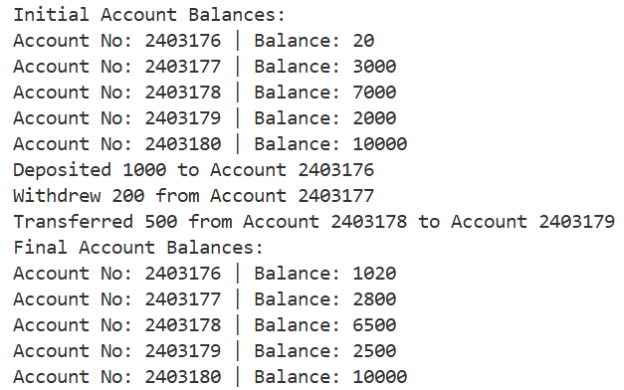
Precautions:
- Ensure withdrawal or transfer amount ≤ balance
- IDs should be unique
Conclusion:
Deposits, withdrawals and transfers were performed successfully. The Account class allowed secure and organized management of balances, demonstrating object-oriented principles in a simple banking system

Problem 3: Triangle Class
Objective:
- To create a Triangle class
- To initialize edges, check validity and calculate the area
Theory:
A triangle is defined by its three edges. A triangle is valid if the sum of any two edges is greater than the third edge. The area can be calculated using the formula: s = (a+b+c)/2 and Area = sqrt(s*(s-a)*(s-b)*(s-c)). Using a class allows both the edges and the methods for validation and area calculation to be combined in one structure
Code:
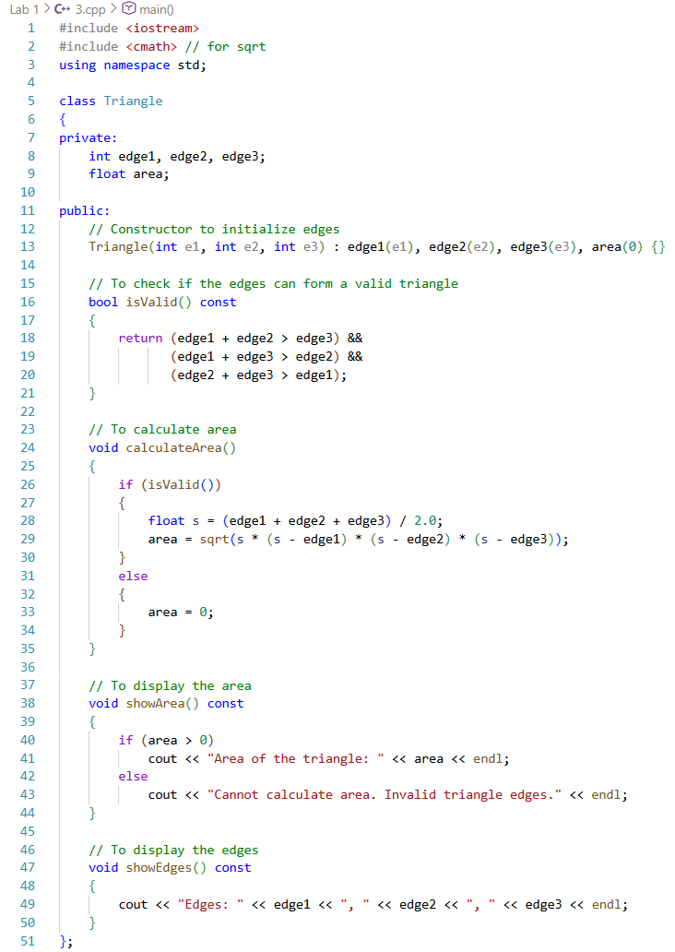
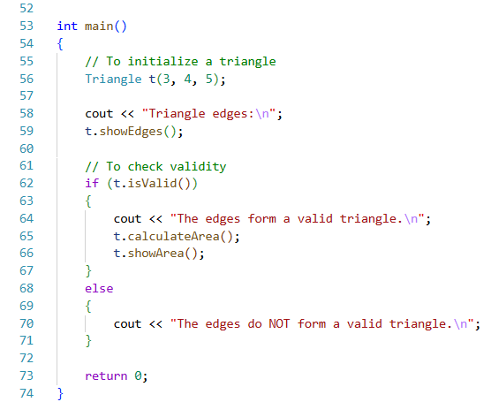
Procedure:
- The Triangle class was created with three edges as private members
- Validity was checked using the triangle inequality rule
- Area was calculated
- The area was displayed for valid triangles
Output:
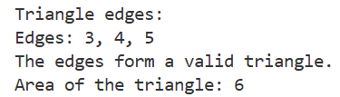
Precautions:
- Edges must be positive
- Check validity before calculating area
Conclusion:
The Triangle class successfully verified triangle validity and calculated its area. Object-oriented principles allowed encapsulation of edges and operations efficiently

Problem 4: Gym Member
Objective:
- To create a Member class for gym members
- To calculate BMI and classify members’ health status
- To find min, max and average height & weight
Theory:
Each member has an ID, height and weight. BMI is calculated using the formula BMI = Weight / Height² and the member is classified as underweight, normal, overweight, or obese according to standard BMI ranges. Classes make it easy to handle multiple members and perform operations like min, max, average and BMI classification
Code:
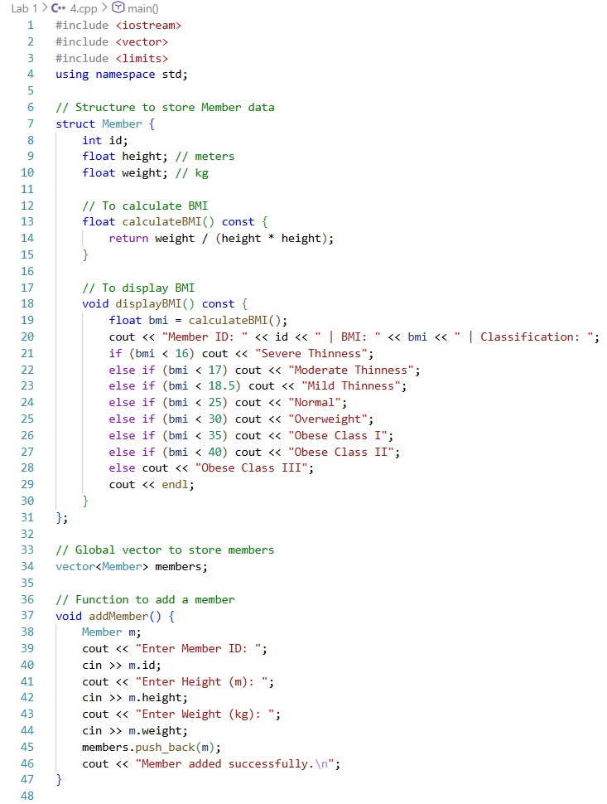
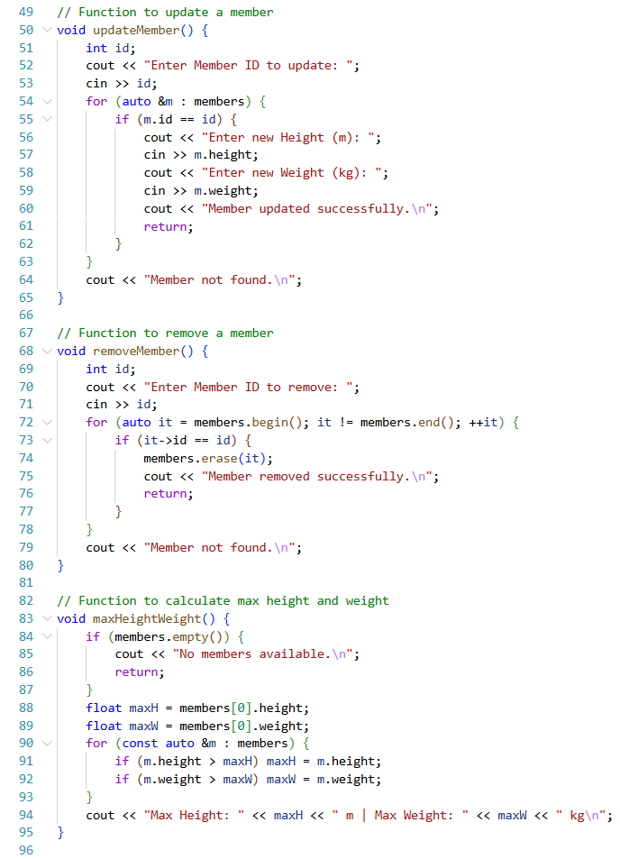
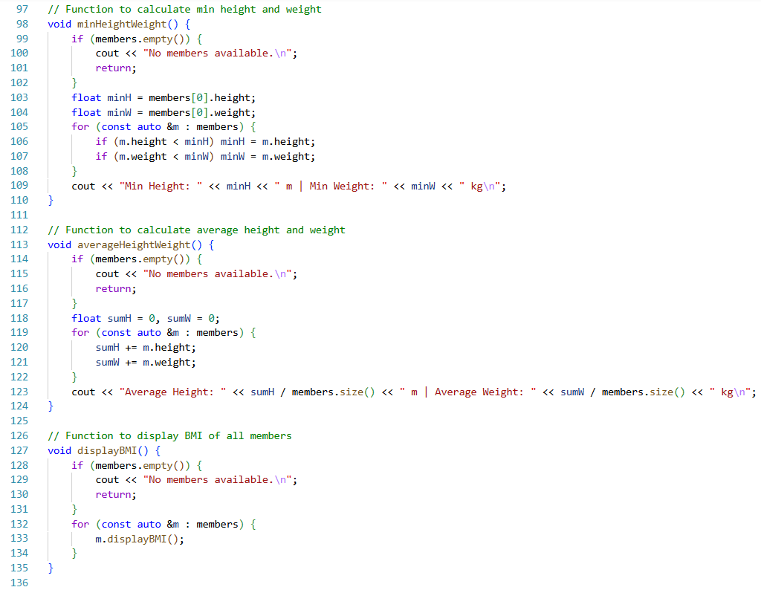
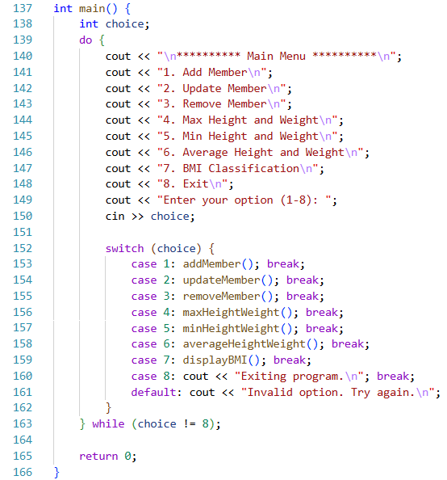
Procedure:
- The Member class was created with ID, height and weight
- Members were added, updated and removed from the system
- BMI was calculated and classification was displayed
- Min, max and average height & weight were calculated and displayed
Output:
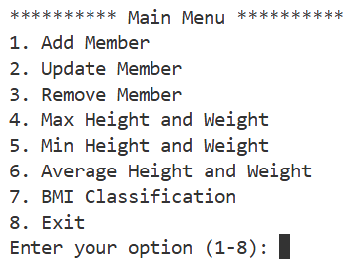
Precautions:
- Enter positive height and weight
- IDs must be unique
Conclusion:
BMI calculations and member management were successfully implemented. Object-oriented programming was used to organize multiple members efficiently and statistical operations were applied accurately

Problem 1: Test Class

Objective:
- To create a Test class with multiple constructors
- To track the total number of objects created
- To perform operations using object data members

Theory:
In object-oriented programming, constructors are used to initialize objects in different ways such as default, parameterized and copy constructors. A static data member is shared among all objects of a class and is useful for counting how many objects are created. Encapsulation ensures that data members remain protected while methods control access to them

Code:
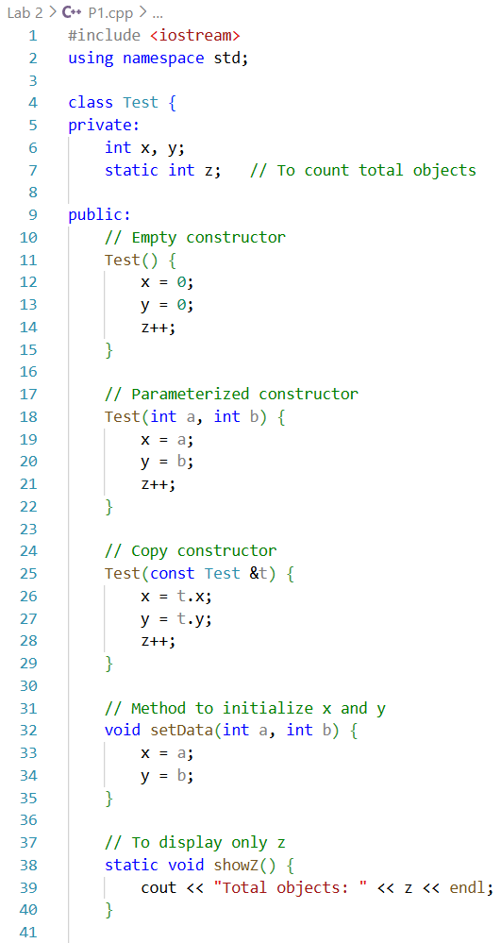
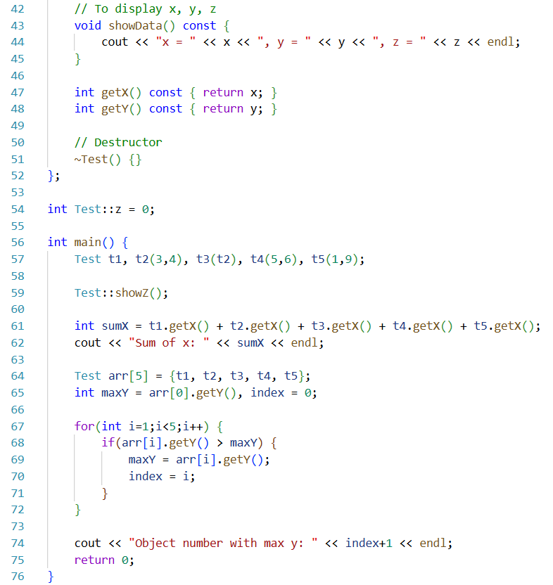

Procedure:
- The Test class was created with private data members x, y and static z
- Constructors were implemented to initialize data in different ways
- Five objects were created using different constructors
- The sum of x values and maximum y value were calculated
- Destructor was defined for object cleanup

Output:
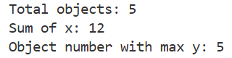

Precautions:
- Static variable must be defined outside the class
- Copy constructor should receive object by reference
- Constant methods should not modify data members

Conclusion:
The Test class successfully demonstrated the use of constructors, static data members and object operations. Object counting and data analysis were performed correctly, showing proper use of object-oriented programming concepts

Problem 2: Copy Constructor

Objective:
- To create a class with two data members
- To use setter method and copy constructor

Theory:
A copy constructor is used to create a new object by copying data from an existing object. Setter methods help initialize private data members safely. This approach ensures controlled access and proper duplication of object data

Code:
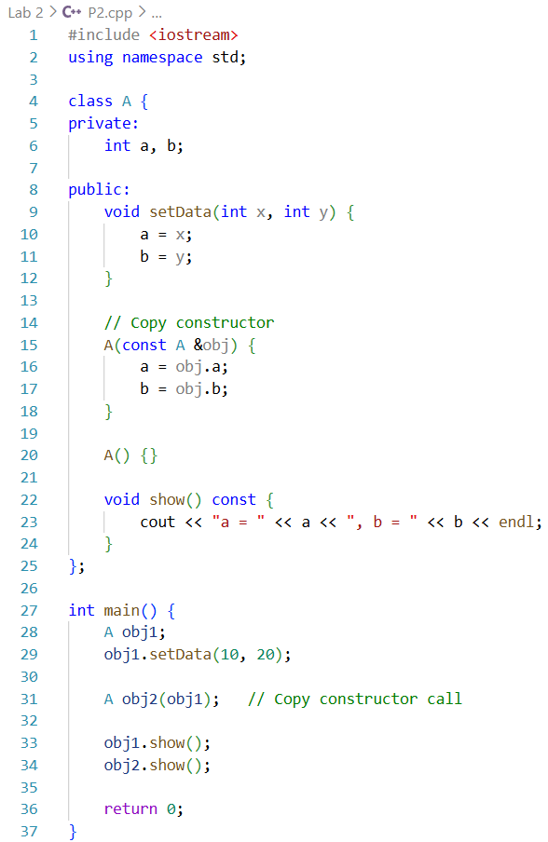

Procedure:
- The class A was created with two private data members
- Setter method was used to assign values to obj1
- Copy constructor was used to copy data from obj1 to obj2
- Values were displayed for verification

Output:
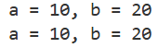

Precautions:
- Copy constructor must accept reference parameter
- Setter method should be used before copying data
- Private members should not be accessed directly

Conclusion:
The program successfully demonstrated the use of setter methods and copy constructors. Object data was copied correctly, ensuring safe and structured duplication of objects

Problem 1: Father → Son → GrandSon Inheritance

Objective:
- To create a multi-level inheritance hierarchy: Father → Son → GrandSon
- To explore access to private, protected and public members in derived classes
- To calculate the sum of accessible members in GrandSon class

Theory:
Inheritance allows a class to acquire members and methods from another class. Access specifiers (private, protected, public) control which members are accessible in derived classes. Multi-level inheritance demonstrates how access modifiers affect visibility across different levels of hierarchy. By testing various inheritance types, one can see which members are accessible in Son and GrandSon classes and how sums of accessible members can be calculated

Code:
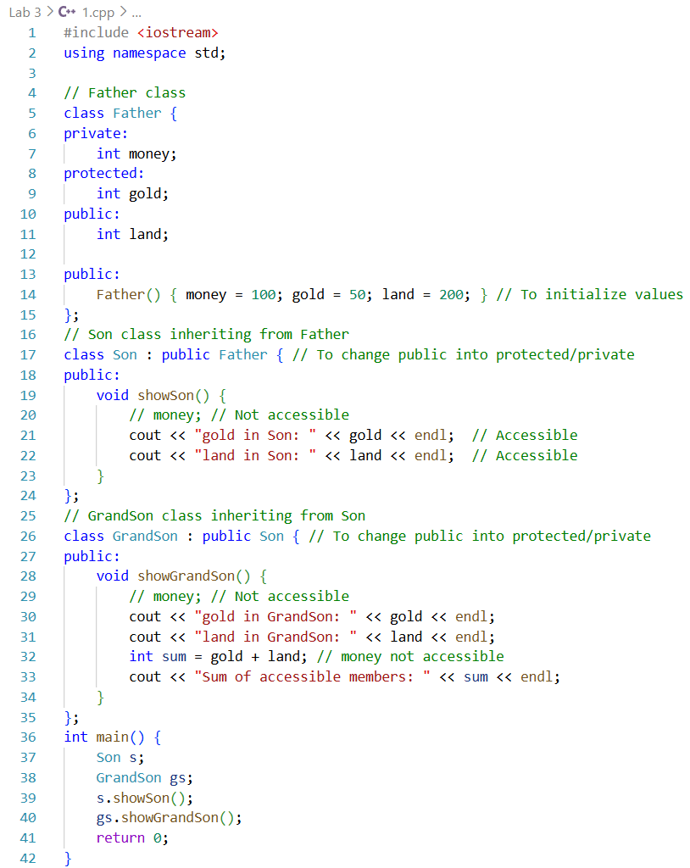

Procedure:
- The Father class was created with private, protected and public members
- The Son class was derived from Father with public inheritance
- The GrandSon class was derived from Son with public inheritance
- Accessible members in Son and GrandSon classes were tested and displayed
- Sum of accessible members in GrandSon class was calculated
- Different inheritance types were tested by modifying access specifiers

Output:
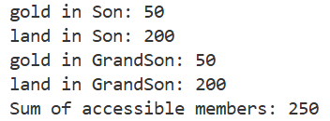
- Son class: gold and land accessible; money not accessible
- GrandSon class: gold and land accessible; money not accessible
- Sum of accessible members in GrandSon class displayed correctly
Class |  | In Son Class |  |  | In GrandSon Class
Son | GrandSon | money | gold | land | money | gold | land
public | public | ✕ | ✓ | ✓ | ✕ | ✓ | ✓
protected | public | ✕ | ✓ | ✕ | ✕ | ✓ | ✕
private | public | ✕ | ✕ | ✕ | ✕ | ✕ | ✕
public | protected | ✕ | ✓ | ✓ | ✕ | ✓ | ✕
protected | protected | ✕ | ✓ | ✕ | ✕ | ✓ | ✕
private | protected | ✕ | ✕ | ✕ | ✕ | ✕ | ✕
public | private | ✕ | ✓ | ✓ | ✕ | ✕ | ✕
protected | private | ✕ | ✓ | ✕ | ✕ | ✕ | ✕
private | private | ✕ | ✕ | ✕ | ✕ | ✕ | ✕

Precautions:
- Private members cannot be accessed in derived classes
- Correct inheritance type must be used based on accessibility requirements
- Display functions should only access allowed members

Conclusion:
The problem demonstrates multi-level inheritance and the effect of different access specifiers. Son and GrandSon classes accessed only allowed members of Father and the sum of accessible members was calculated correctly

Problem 2: Different Types of Inheritance

Objective:
- To learn and test different types of inheritance in C++
- To access private, protected and public members from derived classes
- To understand visibility rules for each inheritance type

Theory:
Inheritance in C++ allows one class to derive properties and behaviors from another class. There are multiple types:
- Single Inheritance: One base, one derived class
- Multi-Level Inheritance: Chain of inheritance (base → derived → derived)
- Multiple Inheritance: One derived class inherits from multiple base classes
- Hierarchical Inheritance: Multiple derived classes inherit from the same base
- Hybrid Inheritance: Combination of more than one type of inheritance
Access specifiers (private, protected, public) control which members are visible in derived classes

Codes:

Single Inheritance
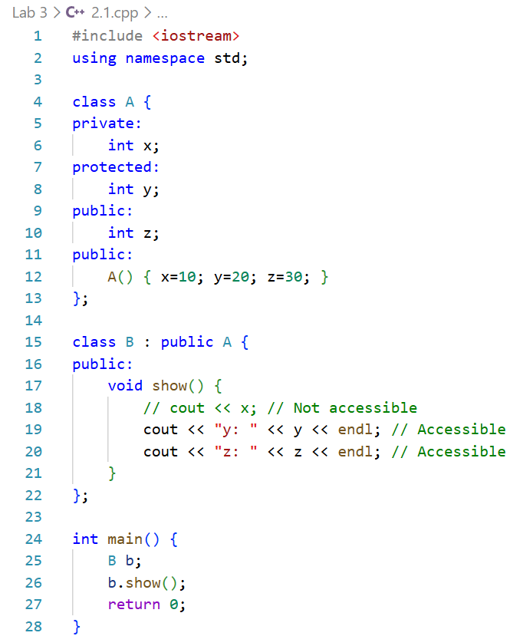
Output:
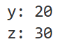

Multi-Level Inheritance
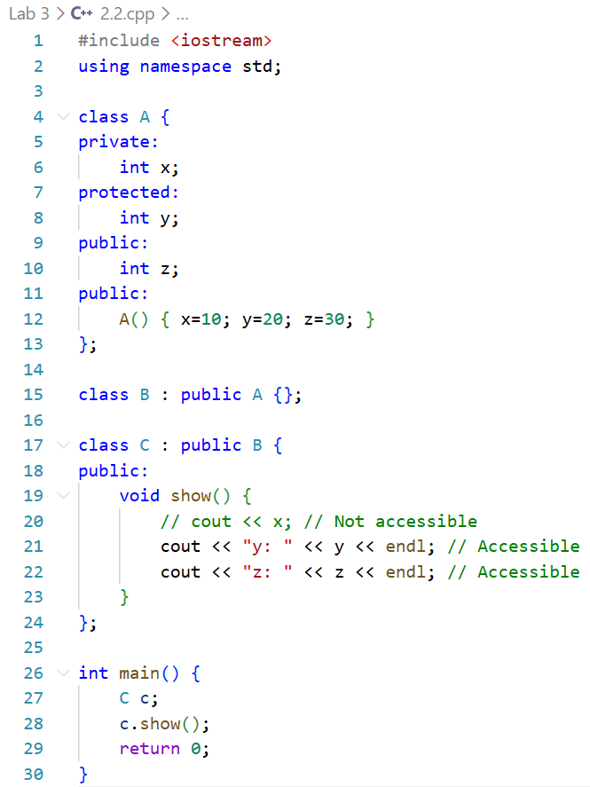

Output:

Multiple Inheritance
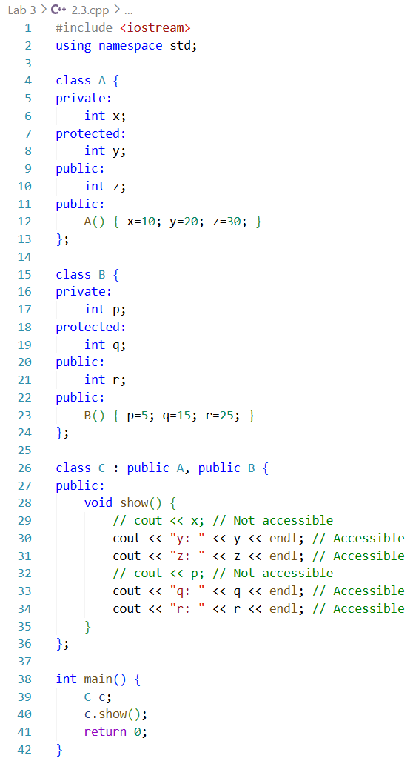
Output:
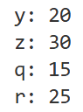

Hierarchical Inheritance
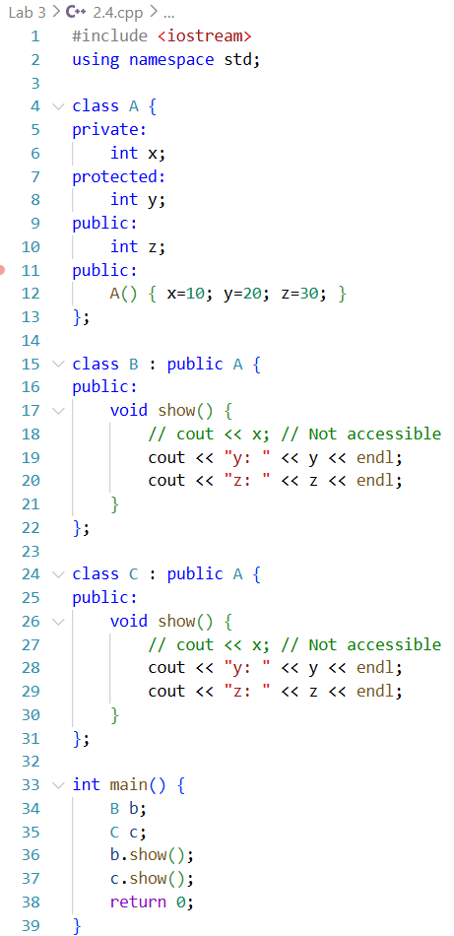
Output:
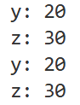

Hybrid Inheritance
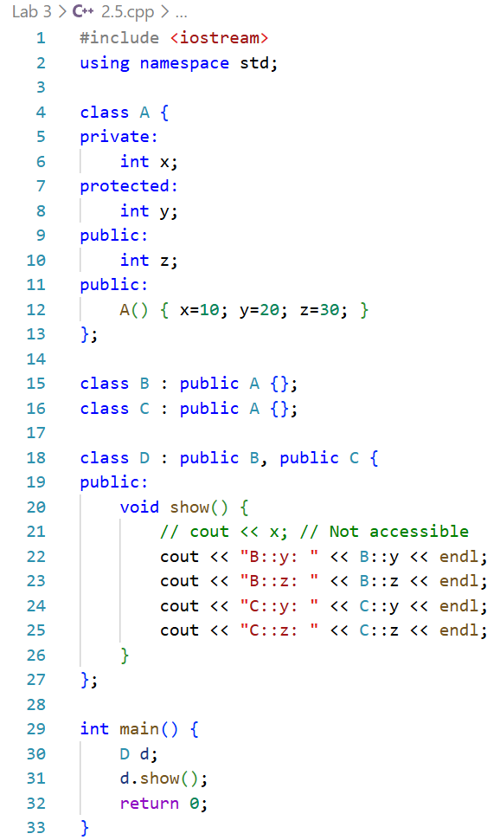
Output:
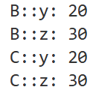

Procedure:
- Classes were created according to the inheritance type
- Derived class methods were written to access base class members
- main() called the methods to observe accessible members
- Each inheritance type was tested separately
- Output: was noted for private, protected and public members

Observations:
- Private members of base classes were never accessible in derived classes
- Protected members were accessible in derived classes depending on inheritance type
- Public members were accessible in public inheritance
- Different inheritance types demonstrated different member accessibilities

Precautions
- Private members cannot be accessed directly in derived classes
- Correct inheritance type must be used for expected access
- Display functions should not try to access inaccessible members

Conclusion
The problem successfully demonstrated all five types of inheritance in C++. Access specifiers correctly controlled visibility in derived classes. Multi-level, multiple, hierarchical and hybrid inheritance types were successfully tested, showing how inheritance type and access specifiers influence accessibility

Problem 3: Constructors & Destructors in Inheritance

Objective:
- To understand constructor and destructor execution in different types of inheritance.
- To implement constructors and destructors for single, multi-level, multiple, hierarchical and hybrid inheritance.
- To observe and verify the sequence of constructor and destructor calls.

Theory:
In C++, constructors are executed from base class to derived class, while destructors are executed from derived class to base class

Single Inheritance

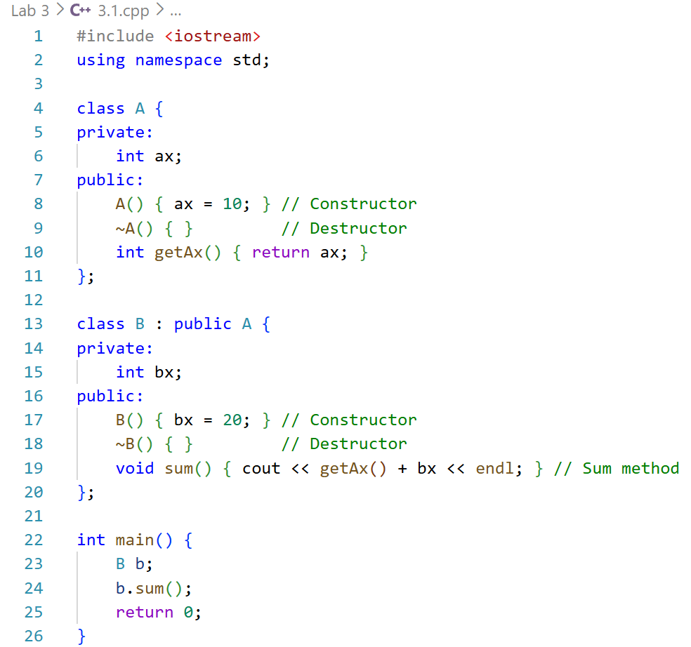
Sequence:
Constructor: A → B
Destructor: B → A
- Multi-Level Inheritance
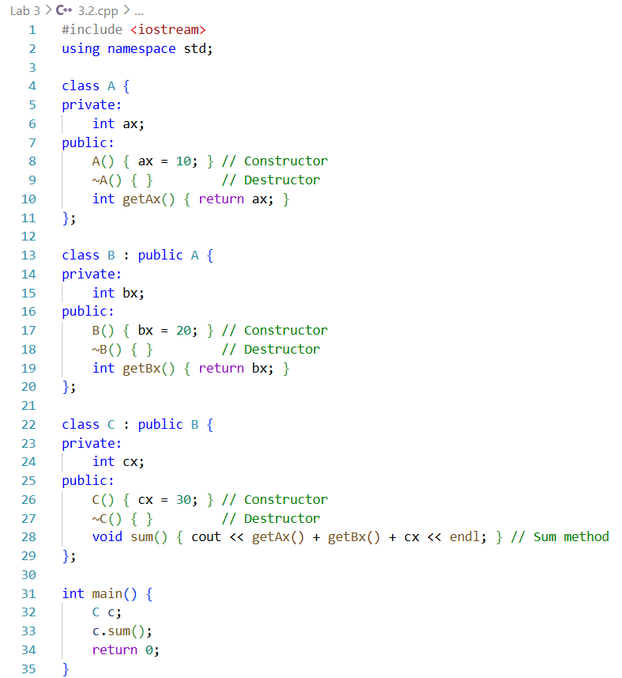
Sequence:
Constructor: A → B → C
Destructor: C → B → A
- Multiple Inheritance
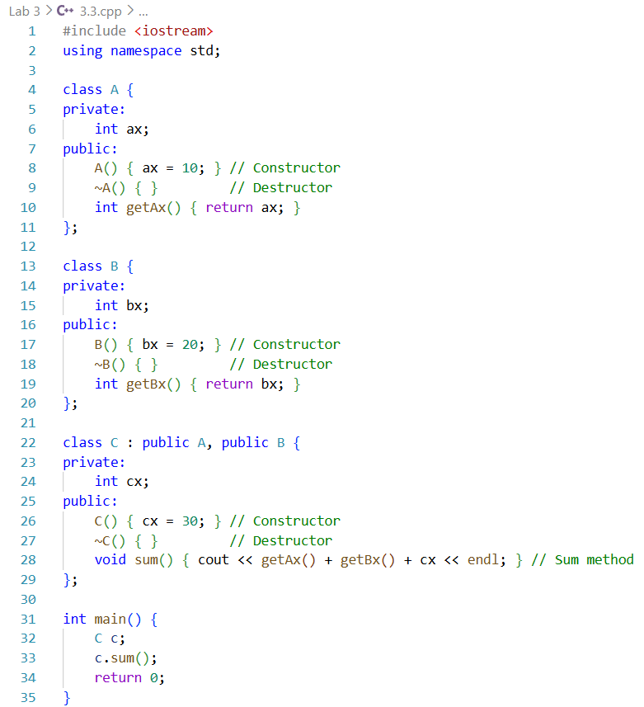
Sequence:
Constructor: A → B → C
Destructor: C → B → A
- Hierarchical Inheritance
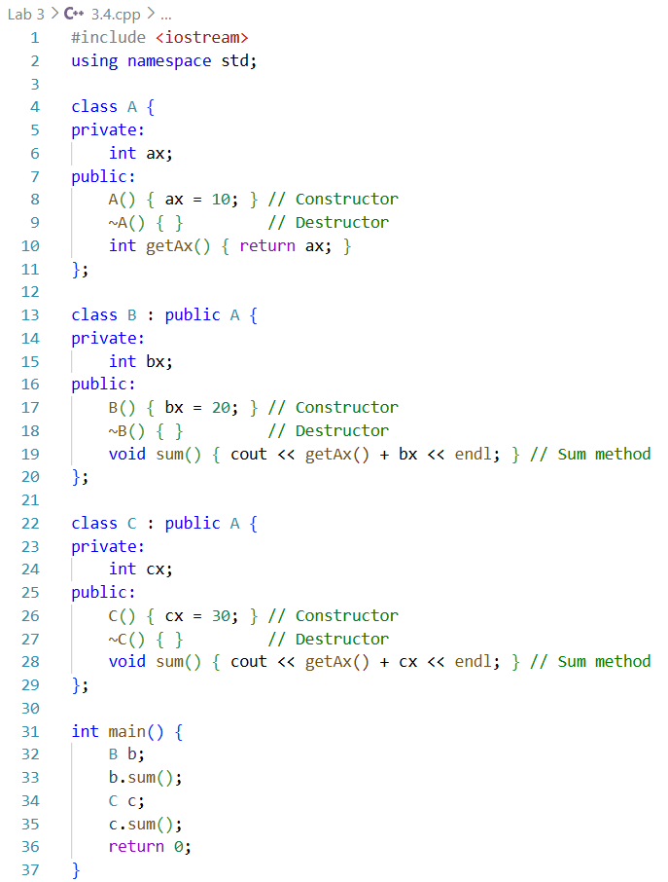
Sequence:
For B: Constructor A → B, Destructor B → A
For C: Constructor A → C, Destructor C → A

Hybrid Inheritance
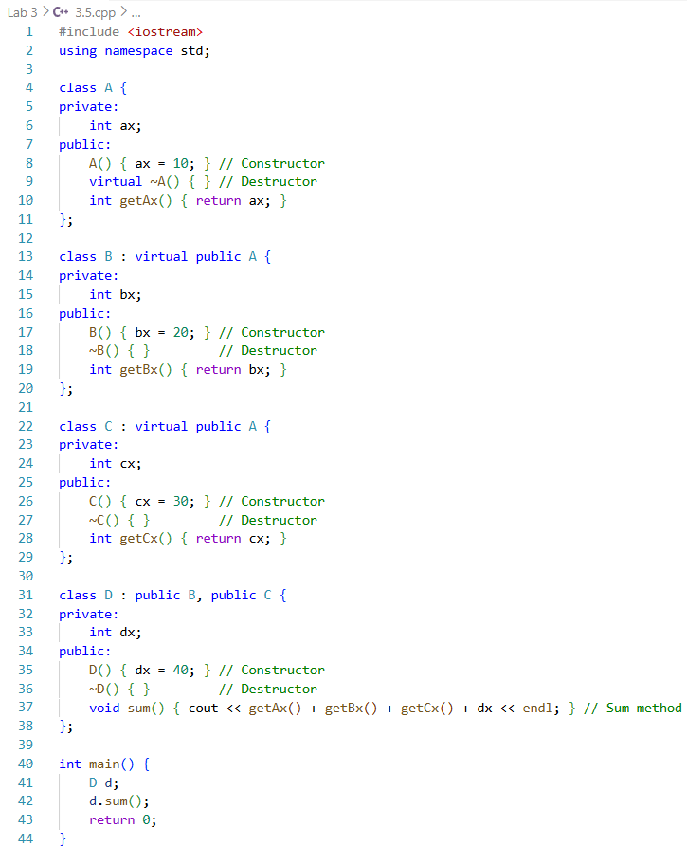
Sequence:
Constructor: A → B → C → D
Destructor: D → C → B → A

Procedure:
- Classes were created with private members and constructors/destructors
- Derived classes implemented their own constructors and destructors
- Methods were written to calculate the sum of all relevant members
- main() objects were created to observe constructor/destructor sequences
- Execution order of constructors and destructors was noted for each inheritance type

Output:
- Constructors always executed from base → derived
- Destructors executed in reverse: derived → base
- Virtual inheritance ensured single construction of shared base class in diamond problem
- Sum methods returned correct results using accessible members

Precautions:
- Always initialize base members properly
- In multiple inheritance, constructors for each base must be correctly called
- For diamond inheritance, use virtual to prevent multiple base construction

Conclusion:
Constructors and destructors in inheritance follow strict sequences: base to derived for construction and derived to base for destruction. This problem demonstrated constructor/destructor execution clearly for single, multi-level, multiple, hierarchical and hybrid inheritance types

Problem 1: Method / Function Overloading

Objective:
- To implement function overloading using a single method nam
- To perform summation of different types and numbers of values

Theory:
Function overloading allows multiple functions to have the same name but different parameter lists. The compiler decides which function to call based on the number and type of arguments passed. This improves code readability and flexibility by using one logical function name for related operations

Code:
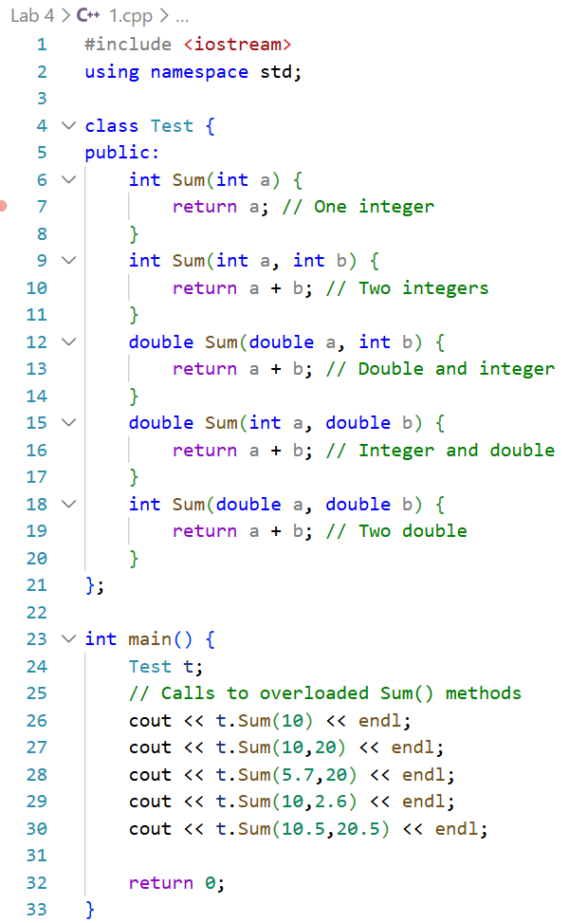

Procedure:
- A Test class was created
- The Sum() method was overloaded with different parameter types
- Function calls were made from main()
- Returned values were displayed

Output:
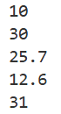
- Sum(10) → 10
- Sum(10,20) → 30
- Sum(5.7,20) → 25.7
- Sum(10,2.6) → 12.6
- Sum(10.5,20.5) → 31

Precautions:
- Parameter types must differ clearly
- Return type alone should not differ
- Proper data types must be used

Conclusion:
Function overloading was implemented successfully. The program correctly selected the appropriate Sum() method based on function arguments, demonstrating compile time polymorphism

Problem 2: Operator Overloading

Objective:
- To calculate current in an AC circuit using operator overloading
- To represent complex numbers using a class

Theory:
In AC circuits, impedance and voltage are represented as complex numbers. Operator overloading allows arithmetic operations on user defined objects like complex numbers. This simplifies calculations and makes the code more intuitive and readable

Code:
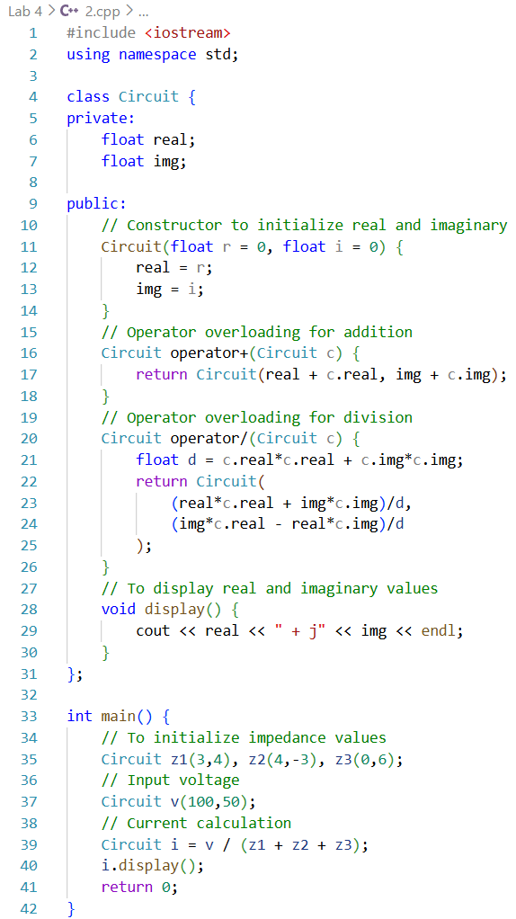

Procedure:
- The Circuit class was created to represent complex numbers
- Operators were overloaded for addition and division
- Impedances and voltage were initialized
- Current was calculated and displayed

Output:
- Complex arithmetic was performed correctly
- Current value was obtained using overloaded operators

Precautions:
- Division by zero must be avoided
- Correct formula for complex division should be used

Conclusion:
Operator overloading simplified complex number calculations. The circuit current was computed correctly, demonstrating effective use of operator overloading

Problem 3: Unary Operator Overloading

Objective:
- To control TV sound using unary operator overloading.
- To increase and decrease sound using operators.

Theory:
Unary operator overloading allows operators like ++ and -- to be redefined for user-defined classes. This is useful for controlling incremental changes such as sound level in a TV remote system.

Code:
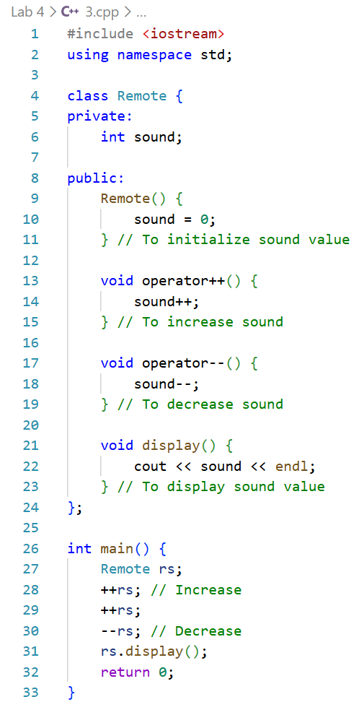

Procedure:
- A Remote class was created
- Unary operators ++ and -- were overloaded
- Sound level was increased and decreased
- Final sound value was displayed

Output:
- Sound increased on ++ operation
- Sound decreased on -- operation
- Final sound level displayed correctly

Precautions:
- Sound should not exceed limits
- Initial sound value should be defined

Conclusion:
In this problem, Unary operator overloading was implemented successfully to control the sound levels of a TV remote. Each operator (++ and --) correctly modified the private sound data member as intended, simulating the increase and decrease of volume. The program demonstrated how unary operators can be customized for user-defined classes, and the final output verified that the remote responded accurately to multiple button presses. This exercise reinforced the concept of operator overloading and showed its practical application in modeling real-world devices

Problem 4: Friend Function

Objective:
- To calculate total money using friend function
- To access private data members of two classes

Theory:
Friend functions are special functions in C++ that are granted access to the private and protected members of one or more classes. This capability is particularly useful when operations require combining or manipulating data from multiple classes while still preserving the principles of encapsulation and data hiding, allowing controlled interaction between class internals without exposing them publicly

Code:
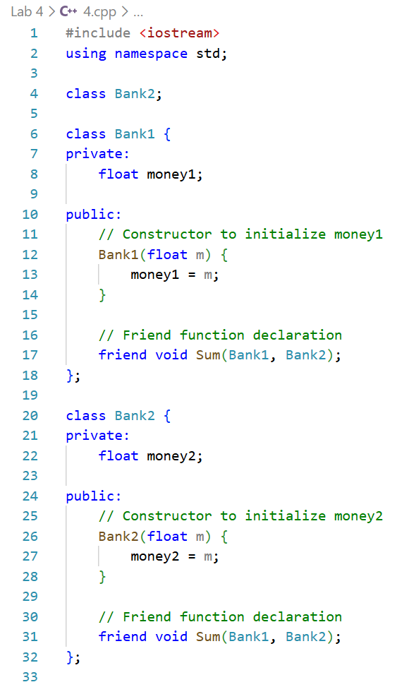
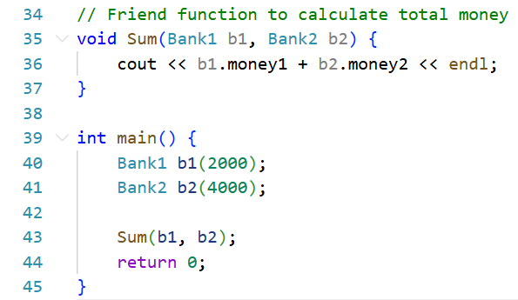

Procedure:
- Two bank classes were created with private money variables
- A friend function was declared and defined
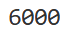
- Total money was calculated and displayed

Output:
- Correct total money was displayed
- Private data was accessed successfully

Precautions:
- Friend functions should be used carefully
- Class relationships should be clear

Conclusion:
The friend function successfully accessed private data members from two classes. Total money calculation was performed correctly, demonstrating controlled data sharing

